Adam Gincel

HAR495

Final Project Proposal

The topic of this final project is the *content* of video games. Throughout this semester many of the games we played had me thinking about what content really was – how was it even possible to compare the content of a simple social game like Mafia to the symbolic lifetime journey of *Journey*? Of all of the types of *content* within games, I had never really given much thought to the idea of games as history teachers. *1979 Revolution: Black Friday* really made me think critically about what kind of role games could play in the teaching of recent, nuanced history that one had never been exposed to before. I was never the best history student, but *1979* drew me in like no history lecture, book, or show has before. As such, I want to focus on discussions of informative history, as the content I analyze for my final project.

I went on *1979’s* Steam page, and searched through the historical tag, but didn’t find too much of what I was looking for. Sid Meyer’s Civilization, Assassin’s Creed, and other more generic war and strategy games kept coming up – these are games that use history as a backdrop to tell their own stories. I am looking for a game whose story is history, or is at least enveloped in it. *1979* tells the story of Reza Shirazi, as he navigates through an enormous historical event that unfolds before his, and the player’s, eyes. His story is our eyepiece into the story, but that story is trying to be historically accurate and informative, as well as engaging. I am looking for more games of this nature, and would love suggestions.

One option I could take is playing an Assassin’s Creed game and analyzing how its use of history and *1979’s* use of history are very different. However, I would rather compare two historical games, if possible.

*Visual References:*

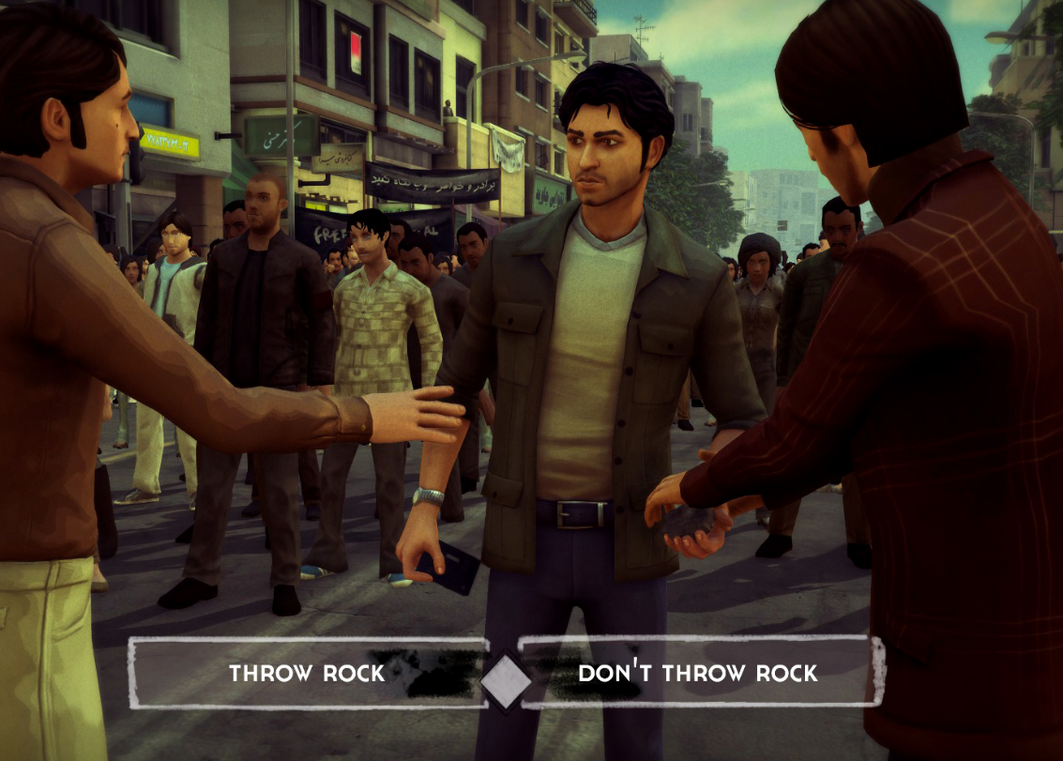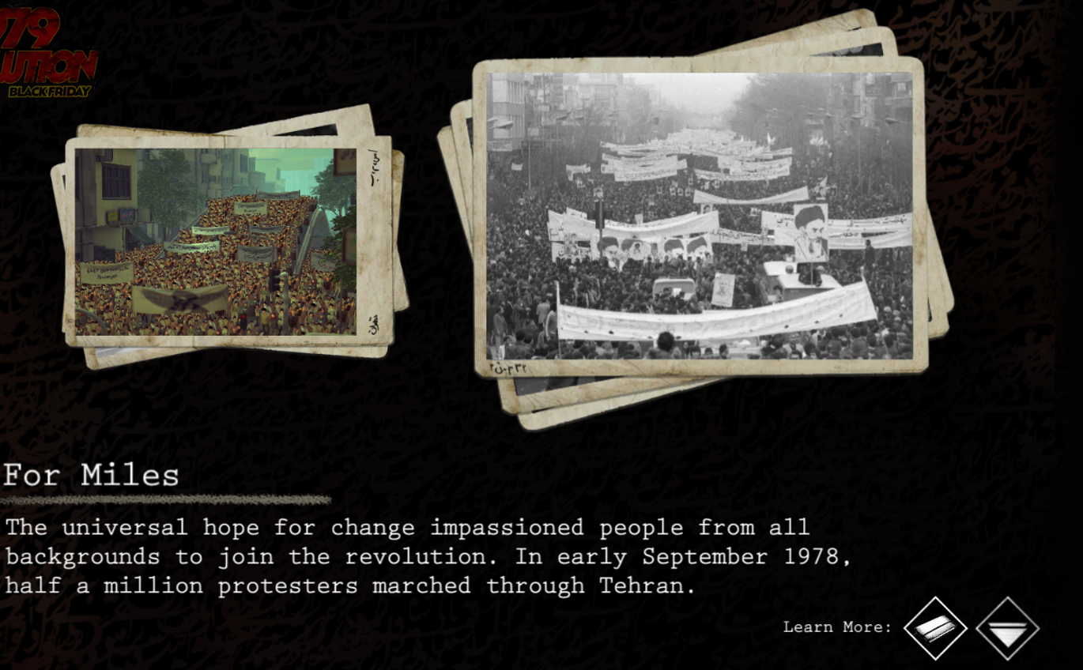

*Assassin’s Creed III,* if relevant*:*

